Efficient file management is a critical requirement in Linux-based systems, especially for system administrators and cyber security professionals. Linux provides powerful command-line utilities that allow users to create, copy, move, rename, view, and delete files efficiently. Understanding these commands is essential for organizing data, managing logs, and automating tasks using scripts.
The problem is to practice Linux commands for deleting, copying, moving, renaming, and displaying files, and to understand the use of input/output redirection for managing command outputs.

Theory

File Management Commands
Linux offers several commands to manage files:
- touch – Create empty files
- cp – Copy files or directories
- mv – Move or rename files
- rm – Delete files or directories
- cat – Display file contents

Input/Output Redirection
Redirection allows command outputs to be redirected to files instead of the terminal:
- > – Redirect output (overwrite)
- >> – Redirect output (append)
- < – Redirect input
These features are essential for scripting and automation.

Commands Used
touch | Create empty file
cp | Copy files
mv | Move or rename files
rm | Remove files
cat | Display file contents
> | Output redirection
>> | Append output

Procedure
- Log in to the Linux system and open the terminal.
- Create a working directory:
mkdir file_ops cd file_ops
- Create files using touch:
touch file1.txt file2.txt
- Add content to files using redirection:
echo "This is file1" > file1.txt echo "This is file2" > file2.txt
- Display file contents:
cat file1.txt
- Copy a file:
cp file1.txt copy_file1.txt
- Rename a file:
mv file2.txt renamed_file2.txt
- Move a file to another directory:
mkdir backup mv copy_file1.txt backup/
- Append content to a file:
echo "Additional content" >> file1.txt
- Delete a file:
rm renamed_file2.txt
- Verify changes using:
Ls

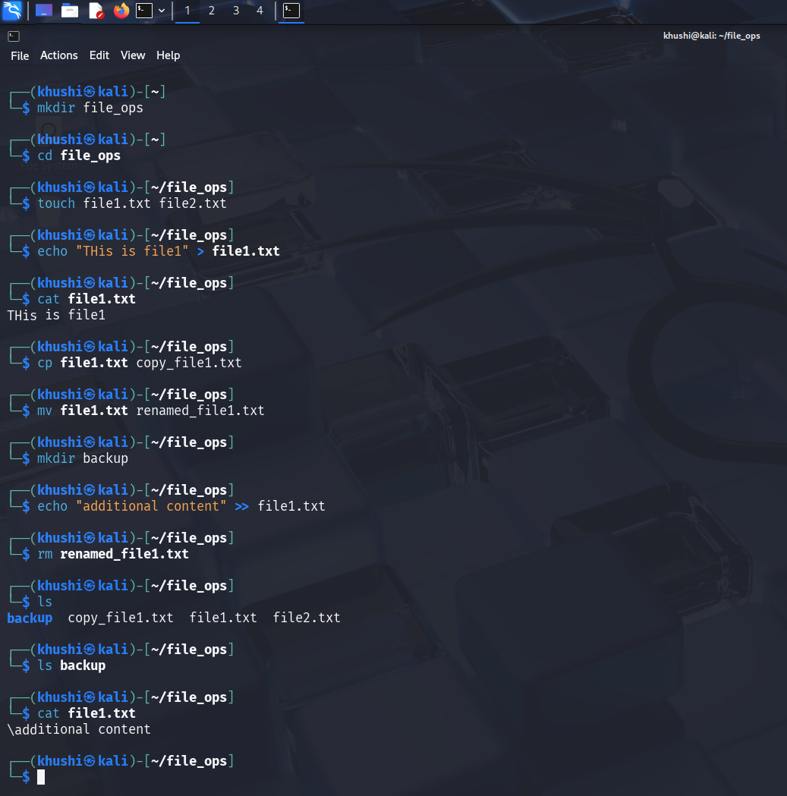

Result
Linux file operations including copying, moving, renaming, deleting files, and output redirection were successfully performed using command-line utilities.

